Carbon Offset/Reduction Project
Dr. Lynn Fletcher, Salem State University
BIO208 Fall 2012

Editors Note: This lesson plan illustrates how a faculty member can include a class activity involving conservation in a college course.

Purpose: To demonstrate that our actions can and do make a difference for the planet, especially when we combine our efforts with others!

Goal: Through our combined actions, we will offset or reduce 25,000 lbs of CO₂!

Background: The majority of our daily activities produce a carbon footprint. Driving and flying are obvious examples since they release CO₂ directly into the atmosphere. Less obvious examples include electricity consumption, appliance usage, and water usage. Most of our electricity in the US comes from coal-fired plants, which release large amounts of CO₂, and the whole process of water treatment and delivery also uses energy. As we become aware of the activities that affect our carbon footprint, we can choose more sustainable alternatives. For example, we can seek less carbon-intensive modes of transportation, use energy efficient appliances and light bulbs, turn off unused appliances, take shorter showers, hang up clothes to dry, etc. These are all fairly simple steps that individuals can take to make a difference. Of course, some activities are difficult to avoid, such as flying. For those, it is possible to reduce our carbon footprint by purchasing carbon offsets.

Project: In this project, you will:
- identify areas where you can reduce or offset your carbon footprint between now and Dec 10th (note – offsetting holiday travel counts!)
- quantify the number of pounds of CO₂ that you reduced or offset in this time period
- enroll at least 1 other person in your life (and NOT in this class) to reduce or offset part of their carbon footprint. Quantify the number of pounds of CO₂ that they are able to reduce or offset.
- Write a brief 1-2 page description of the actions you took to reduce/offset your carbon footprint. Things to consider:
- Was it easy or difficult?
- Did it make you more aware of the impact of your activities?
- Did you feel like your action of reduction/offset makes a difference?
Also describe how you convinced a friend or family member to join you in this endeavor.
- Did you use any of the material discussed in class? Were they inspired to make a difference?

Grading: 65 points total: (#1-3) 10 pts each; (#4) 20pts; 5pts for each complete update

Due Dates:
Friday Nov 16th – report on Canvas the # of pounds of CO₂ that you reduced or offset
Identify who else in your life is participating in the project
Friday Nov 30th – report any ADDITIONAL CO₂ that you reduced or offset
Friday Dec 7th – report any ADDITIONAL CO₂ that you reduced or offset
Monday Dec 10th – Project due. Turn in brief report along with a separate tally of the TOTAL pounds of CO₂ reduced/offset by you and your friend or family member. Indicate date and activities for each reduction/offset. ***Use the template form provided on Canvas***

Information to help with reduction and offsets:

Websites for reputable carbon offsets (based on Suzuki Foundation Report):
Top Three Sites
- Less – www.less.ca (best for airplane travel or long car trips, over 100 miles)
- Climate Care- http://www.climatecare.org/
- Atmosfair - https://www.atmosfair.de/en/home/ (German site, may have to click for English translation)
Two others
- Planetair – http://www.planetair.ca/ * (I use this one)
- Terrapass - http://www.terrapass.com/

Pounds of CO₂ per mile for Different Forms of Transportation
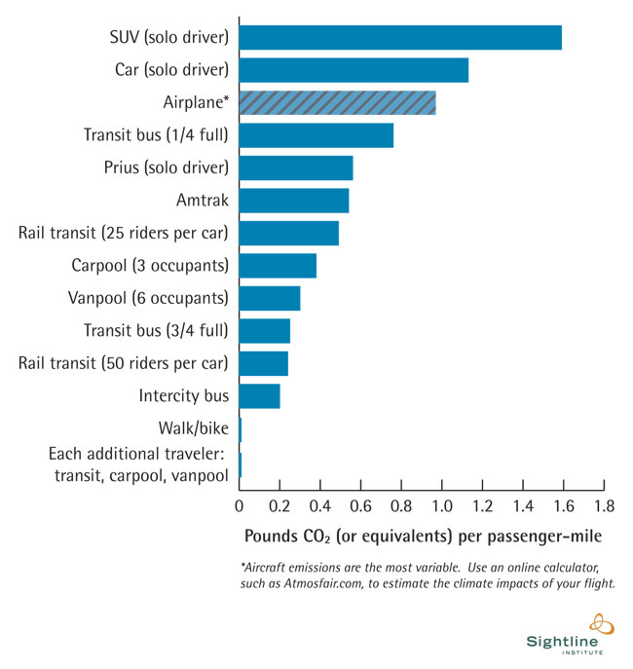
Example of how to use this chart for reduction or offset:
- If you were planning to drive alone to Boston but instead decided to take a train, you would switch from emitting 1.2 lbs to emitting 0.25 lbs CO₂ per mile. That is a REDUCTION of 0.95 lbs CO₂ per mile. If it was 30 miles round trip, that is a total reduction of
30miles x .95lbs/mile = 28.5 lbs CO₂

Chart of Energy Usage and Pounds of CO₂ Emitted per week in One Household
- You can use this information to estimate how much CO₂ you produce in different activities like drying clothes, taking a shower, watching TV, etc. From here you can modify your activities and calculate your REDUCTION in CO₂.

For example - from the chart you can figure out how many pounds of CO2 are used for putting your clothes in the dryer for 1 hour: 219.2 lbs CO2 represents 8 hrs of drying per week over 4 weeks, 8 x 4= 32 hours. Divide 219.2 lbs by 32 hours = 6.8 lbs CO2. Therefore, if you decided to hang your clothes to dry, you would REDUCE your CO₂ footprint by 6.8 lbs.

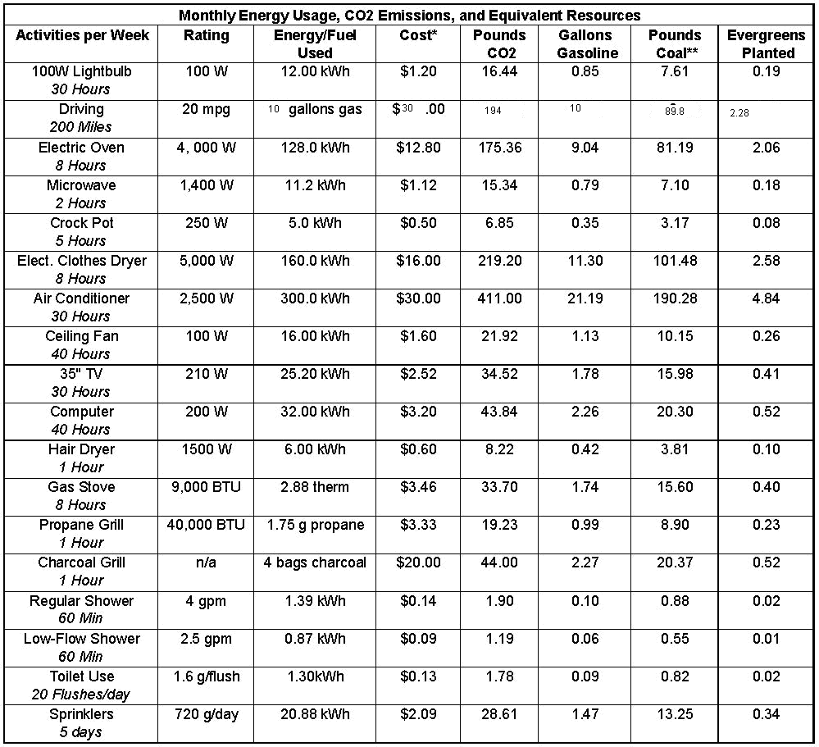
http://www.science20.com/science_mom/i_wanna_go_green_so_show_me_the_math

Other helpful numbers and conversions:

Information on energy used to make disposables
(source: http://www.worldcentric.org/sustainability/energy-savings)

1 styrofoam plate = 0.237 kwh
1.52 lbs CO2/kwh * 0.237 kwh = 0.36 lbs CO2 per plate

1 plastic utensil = 0.144kWh
1.52 lbs CO2/kWh * 0.144kWh = 0.219 lbs CO2 per utensil

Disposable coffee cup
(source: http://www.carbonrally.com/challenges/12-Paper-Coffee-Cups)
1 disposable coffee cup = 0.25 lbs CO2 (waxed paper)

Electricity
Average emissions factor is 1.52 lbs CO2 per kWh (http://www.epa.gov/cleanenergy/energy-resources/refs.html)
(kilowatt hour – energy unit equivalent to 1000 watts of electricity used for 1 hour)
In order to determine the CO2 emissions for an appliance, you need to know how many watts it uses…some things tell you the watts, such as light bulbs, but other appliances you may have to look up. For example, an average oven uses 4000W while a crockpot uses 250W.

You can determine how many kWh of energy are used as long as you know the length of time that the appliance was operated:
Oven: (4000 W) x (1 kW/1000 W) x (2 hours) = 8 kWh
Crock-pot: (250 W) x (1 kW/1000 W) x (5 hours) = 1.25 kWh

To get amount of CO2:
8kWh x 1.52 lbsCO2/kWh = 12.16 lbs CO2
1.25 kWh x 1.52 lbs CO2/kWh = 1.9 lbs CO2

BIO208 Fall 2012 Name: _________________________
Low “Carb” Lifestyle – Project Form
Please submit this form along with your reflective paper ELECTRONICALLY on Canvas by Dec 10th

List the activities you and your friend/family did to reduce/offset CO₂ emissions during the project (remember that you can include travel offsets or carpooling, etc. for winter break):
Activity | Pounds of CO₂ Reduced or Offset

TOTAL lbs. of CO2 Reduced/Offset: _____________________________

Number of people who participated with you: ________

On a separate page, write a brief 1-2 page description of the actions you took to reduce/offset your carbon footprint. Reflect on your experience. Things to consider:
- Was it easy or difficult?
- Did it make you more aware of the impact of your activities?
- Did you feel like your actions of reduction/offset make a difference?
Also describe how you convinced a friend or family member to join you in this endeavor.
- Did you have to teach them about climate change or use any of the material discussed in class? Were they inspired to make a difference?

